ELECENG 2EI4
Design Project #1: DC Power Supply

Jasmine Dosanjh – dosanj5 -- 400531879
February 9, 2025
Table of Contents
Table of Figures 2
Summary 2
Design 4
i. Transformer 4
ii. Rectifier 4
iii. Filter 4
iv. Regulator 4
v. Complete Circuit Schematic 4
vi. Calculations 4
vii. Expected Performance 5
viii. Design Issues 5
Measurement and Analysis 6
Simulation 7
i. Circuit Schematic 7
ii. Netlist 7
iii. Simulation Conditions 7
iv. Simulation Output 8

Table of Figures
Figure 1. Circuit Schematic 3

Summary
This project consists of building a DC power supply that delivers 10 mA at 3V ± 0.1V from a 120V (rms) source at 1kHz. The Analog Discovery 3 device will provide the required sinusoidal input that the transformer would have output if included in the design. The design incorporates a full-wave center-tap rectifier, a filter, and a load. The transformers initial voltage is determined by working backwards using the given information. The focus is on ensuring stable DC output within the tolerance range.

Design

Transformer
The input voltages were theoretically determined to be $V_{in1}=V_{in2}=3.8V.$ Thus, the turns ratio of the Transformer is,
$\frac{E_{P}}{2E_{S}}=\frac{N_{P}}{N_{S}}$ $∵E_{P}→2E_{S}$for center tap
$$\frac{120\sqrt{2}}{2(3.8)}=\frac{N_{P}}{N_{S}}$$
$$∴\frac{N_{P}}{N_{S}}=22.33$$

Rectifier
The topology chosen was a full-wave center tapped transformer. The center tapped transformer was chosen because it uses only two diodes instead of four, making the circuit simpler to analyze. Each diode has a forward voltage drop of 0.7 V. A full-wave rectifier was used instead of a half wave rectifier, as the latter requires a larger capacitance. Since the components kit only included smaller capacitors, the full-wave rectifier was preferred.

Filter
A 25$μF$ filter capacitor was used, connected in parallel with the load resistor. A filter capacitor reduces the ripple from an AC source by storing charge during peaks and releasing it during troughs, which smoothes out voltage fluctuations and provides a more stable DC output.

Regulator
A regulator was not used.

Complete Circuit Schematic
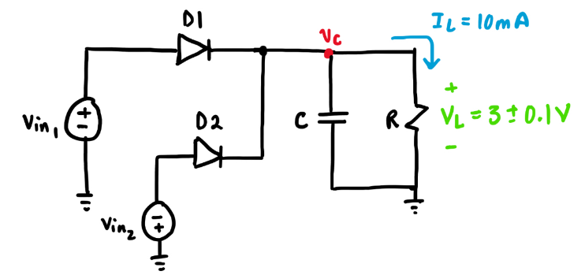
Figure 1. Circuit Schematic

Calculations
$\left(1\right) V_{rpp}=0.1+0.1=0.2 V$
$\left(2\right) By Ohm^{'}s Law, R=\frac{V_{L}}{I_{L}}=\frac{3 V}{10 mA}=300 Ω$
$\left(3\right) V_{rpp}=\frac{I_{L}}{f_{out} C}$ $⟹C=\frac{I_{L}}{f_{out} V_{rpp}}$
$=\frac{I_{L}}{2f_{in} V_{rpp}} ∵f_{out}=2f_{in}$for a full wave rectifier
$=\frac{10 mA}{2\left(1 kHz\right)\left(0.2 V\right)}$
$C=25 μF$
$\left(4\right) V_{D1}=V_{D2}=0.7 V$
$\left(5\right) V_{C,max}=V_{in1}-V_{D1}⟹V_{in1}=V_{D1}+V_{C,max}$
$= 0.7 V+(3 V+0.1)$
$V_{in1}$ $= 3.8 V$
$∴V_{in2}$ $=- 3.8 V$

Expected Performance
The rectifier and filter should provide a DC output voltage with a peak-to-peak ripple of 0.2V, with $V_{out}$within the range of 2.9V to 3.1V

Design Issues
Design Tradeoffs: A larger capacitor would have reduced ripple even more, creating a more accurate DC voltage, but since the components kit has a max capacitance of only 1 $μF$, a full wave rectifier was used.
A voltage regulator could stabilize the output voltage, but the Zener diode in the components kit had a ±5% tolerance, resulting in an output voltage variation exceeding the original input variation of ±0.15% (5% of 3V). Thus, using a regulator would not improve stability and could worsen it.
Design Margins: The capacitor needs to handle 3V, so a CM107 rated for twice the expected voltage (6.3V) was used to avoid damaging the capacitor due to overvoltage.
Component ratings:
$P_{100Ω}=I^{2}R={\left(10mA\right)}^{2}\left(100Ω\right)=10mW$ absorbed
$P_{D1}=V_{C, max}I=(0.7V)\left(10mA\right)=7mW$ absorbed
The resistor dissipates 10mW, which is below its maximum power rating of 25mW, and the diode dissipates 7mW, which is also below its 500mW maximum rating. Thus, both components operate safely.
Safety: To prevent electrical shocks and potential damage to components, the full circuit was simulated before physical testing.

Measurement and Analysis

Simulation

Circuit Schematic
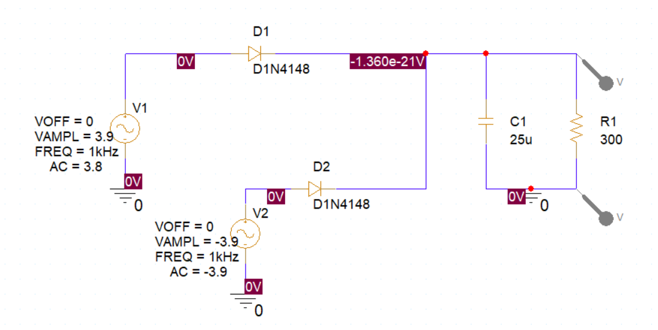

Netlist
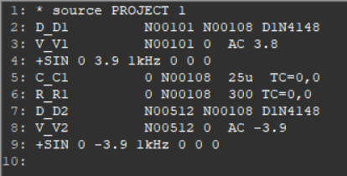

Simulation Conditions
The simulation was run in transient time domain with a 10ms run time. This can be seen in the image below.
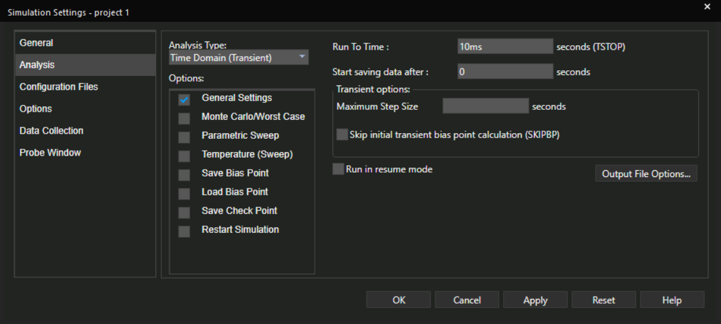

Simulation Output
The simulation output produced a waveform in the range of 2.9V to 3.1V, which meets the design requirements. However, the theoretical input voltage had to be increased from 3.8V to 3.9V, as the initial 3.8V input resulted in an output range of only 2.7V to 2.9V. With this adjustment, the rectifier and filter provide an output voltage of approximately ±3.8V, ensuring that the circuit delivers a final output of 3V ± 0.1V.
